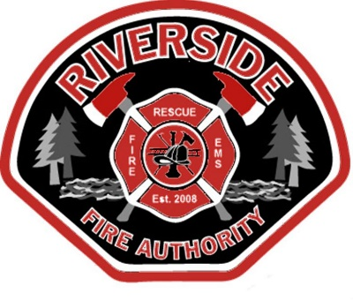
Riverside Fire Authority
Fire Commissioners’ Meeting

AGENDA

February 11, 2026

Station 2
Conference Room

1818 Harrison Ave.
Centralia, WA 98531

360-736-3975

Board of Fire Commissioners

Joe Dolezal
Position No. 1
(2020-2025)

Richard Lennox,
Position No. 2
(2026-2031)

Mike Tomasheck,
Position No. 3
(2022-2027)

Buddy Lowrey,
Position No. 4
(2024-2029)

Mike Rossow,
Position No. 5
(2024-2029)
5:00 P.M. Call to Order
Joe Dolezal, Chair
Mike Tomasheck, Vice Chair

- Pledge of Allegiance

- Approval of Agenda (additions/deletions)

- Public Input or Comment

- Consent Agenda:
- Meeting Minutes (Jan 28, 2026)
- Voucher Approval (Feb. 26-02)
- Payroll

5. Unfinished Business
a.

Administration

Kevin Anderson,
Fire Chief

Erik Olson,
Assistant Chief

Terry Ternan,
Assistant Chief

Stephanie Slorey,
Business Administrator/
Board Secretary

Misty Henning,
Finance Officer/
Asst. Board Secretary

Laura Hanson,
Outreach Coordinator

6. New Business
a.

Good of the Order

Adjournment

